|  |
| --- |
| **National University of Computer and Emerging Sciences** |
| Lab Manual 7  “Views and Stored Procedures” |
|  |
| Database Systems |
| Spring 2018 |

Department of Computer Science

FAST-NU, Lahore, Pakistan

# Exercise

Schema is given in Order.sql file

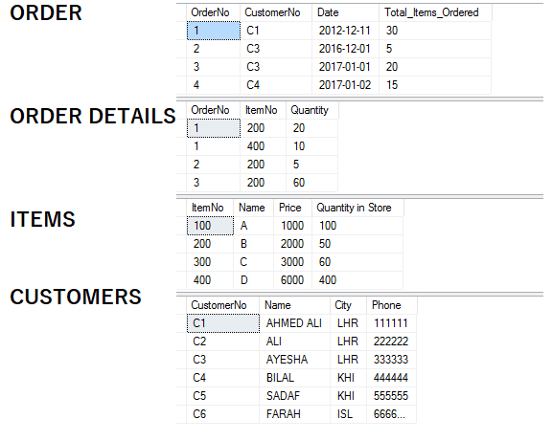

1. Create a View that gives order number and total price of that order (price= item price * item Quantity )
2. Create a View that gives all the items that are doing well in sales. The criteria to judge which item is doing good sale is that the item is has sold more than 20 pieces.
3. Create a stored procedure that takes order number, item No and Quantity as input.

If quantity of that item present in store is less than ordered quantity. Print a message ‘only <quantity in store> is present, which is less than your required quantity is’

If enough quantity is present in store insert the order detail in order table and subtract the ordered quantity from quantity in store, for that ordered item.

Write its Execute Statement as well

1. You have to create a customer Signup procedure, it will take all the information of Customer (No, Name City, Phone).

At the end of procedure it should return a flag (as output parameter) that should tell the violation of following rules:

* 1. Rule1: It should check that the customer No should be unique, so if any existing user has same user number it should return the Flag as 1.
  2. Rule 2: City cannot be null, if city is null it should return flag as 2.
  3. Rule 3: Phone number should be of 6 numbers, if it’s less or more it should flag as 3.
  4. If all the above rules are satisfied then customer should be inserted, and Flag should be returned as 0.

Write its Execute Statement as well

1. You have to create a store procedure to cancel and order, it should take customer number and order no as an input, if that customer has placed that order, the order should be deleted and along with that all of its details should also be deleted. If that order number was not placed by that customer, it should print a message ‘Order no <as taken from input> is not of <CustomerNo><customerName>’ Write its Execute Statement as well
2. Create a view that return StarCustomers, star customers are the customers that have made a purchase of more than 2000.
3. Every customer get 1 point on purchase of 100 Rs. Create a procedure that takes CustomerName as input and return his total points. Write its Execute Statement as well.
4. Create a view that returns all the customers that have phone number not null. One with WITH CHECK option. Also create it without with check option.
   1. Now try to insert, delete and update though the view, and observe the results.